Practical No. 3

Perform the following Operations: Creating Tables (With and Without Constraints). Inserting / Updating / Deleting Records in a Table. Saving (Commit) and Undoing (Rollback).

- Create student table:
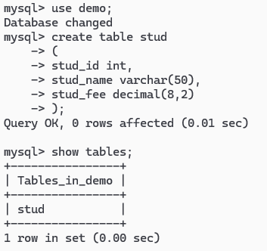
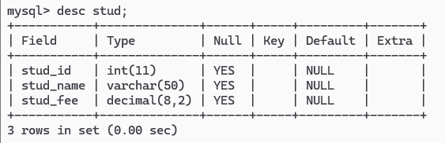

- Insert Data in Table: (Single value insert)
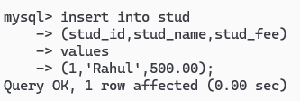
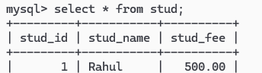

- Insert into multiple values In Single table.
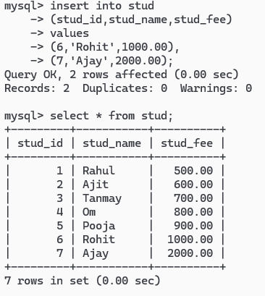

- Using “Where” keyword with Table Data.
Print name of the student where name fees is 500.
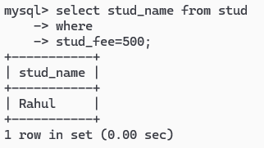

- Find the roll no of the student whose name is Ajit.
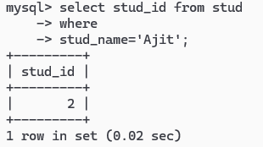
- Find student id, student name where student paid 500.
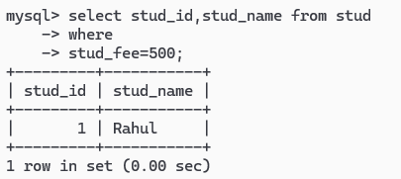

- Find all record of student who paid more than 100 rs as a fee.
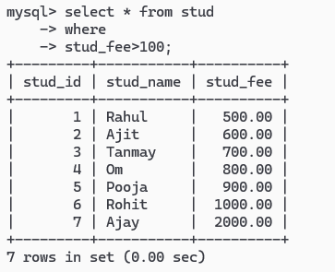

- Print all the data of the student who paid less than 600 as a fee.
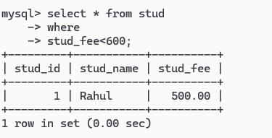

- Update Table Data.
Update student fees to 600, where student name is Rahul.
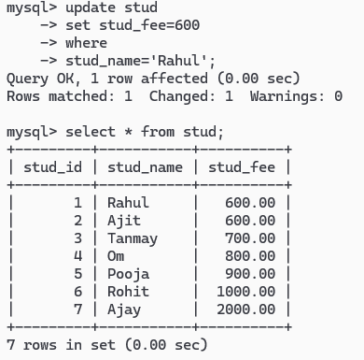

14) Delete all information of student id = 4. (Deletion process with clause)
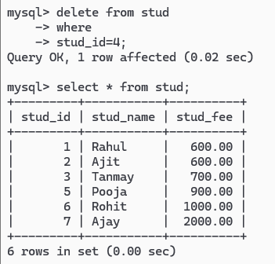

) Delete all record from stud.
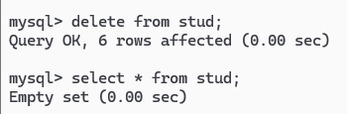

16) Delete the table stud.
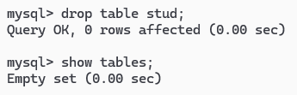

17) Drop the database “demo”.
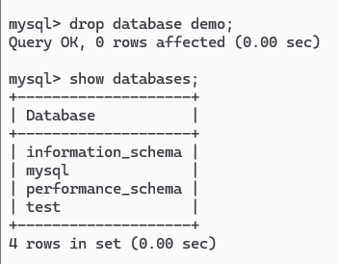

18) Create Constraint Table Using Following Constraint:
i. Primary Key
ii. Not Null
iii. Auto Increment
iv. Default
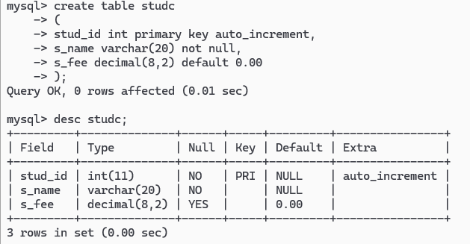
Auto Increment Output:
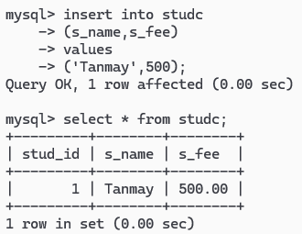

Checking Primary Key Value:
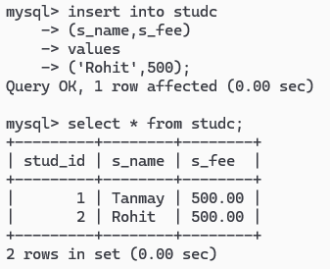
Not Null Output:
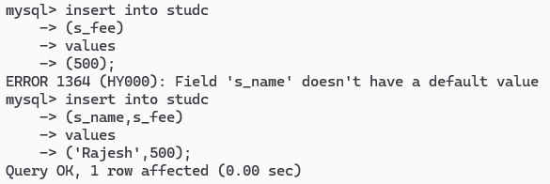
Default Value:
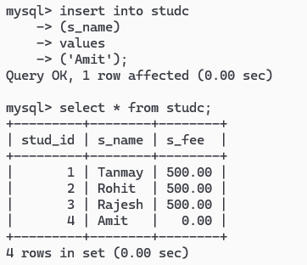

19) Commit and RollBack:


